Q.1 Discuss the factors affecting recruitment?
Ans. The recruitment function of the organisations is affected and governed by a mix
of various internal and external forces. The internal forces or factors are the factors that
can be controlled by the organisation. And the external factors are those factors which
cannot be controlled by the organisation. The internal and external forces affecting
recruitment function of an organisation are:
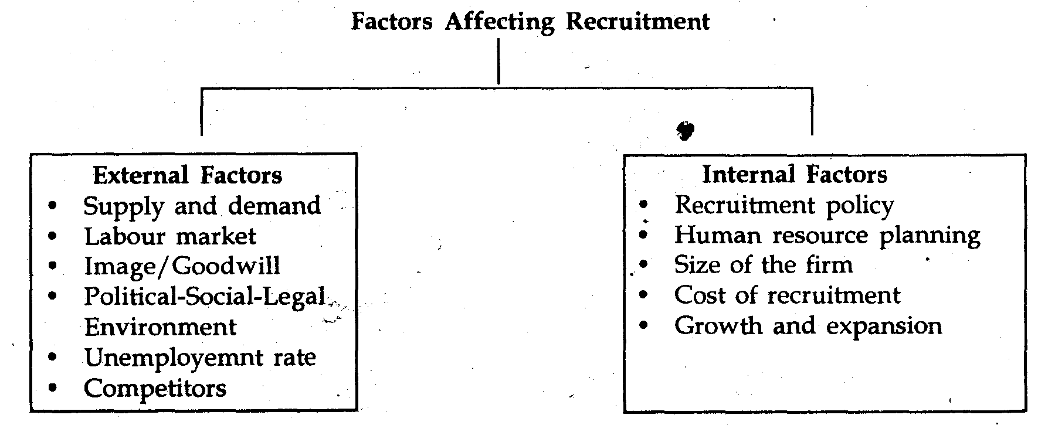

- The, internal factors which can be controlled by the organisation are:
1. Recruitment Policy. The recruitment policy of an organisation specifies the objective of recruitment and provides a framework for implementation of recruitment programme. It may involve organizational system to be developed for implementing recruitment programmes and procedures by ifihing up vacancies with best qualified people.
Factors Affecting Recruitment Policy
• Organizational objectives
• Personnel policies of the organization and its competitors. Government policies on reservations.
Preferred sources of recruitment.
• Need of the organization.
• Recruitment costs and financial implications
2. Human Resource Planning. Effective human resource planning helps in determing the gaps present in the ex sting manpower of the organization. It also helps in determining the number 9f employees to be recruited and what qualification they must possess.
3. Size. of the Firm. The size of the firm is an important factor in recruitment process. If the organization is planning to increase its operauoinis and expand its business, it will think of hiring more personnel, which will handle its operations.
4. Cost. Recruitment incur cost to the employer, therefore, organizations try to employ that source of recruitment which will bear a lower cost of recruitment to the organization for each candidate.
5. Growth and Expansion. Organization will employ or think of employing more personnel if it is expanding it’s operations.
- The external factors which cannot be controlled by the organisation. The major external forces are:
1. Supply and Demand. The availability of manpower both within and outsidthe organization is an important determinant in the reruitment process. If the company has a demand for more professionals and there is limited supply in the market for the professiohals demanded by the company, then the company will have to depend upon internal sources by providing them special training and development programs.
2. Labour Market. Employment conditions in the community where the organization i located will influence the recruiting efforts of the organization If there is surplus of
manpower at the time of recruitment, even informal attempts at the time of recruiting like notice board, display of the requisition or announcement in the meeting etc. will attract more than enough applicants.
3. Image/Goodwill. Image of the employer can work as a potential constraint for recruitment. An organization with positive image and goodwill as an employer finds it
easier to attract and retain employees than an organization With negative image. Image of a company is based on what organization does and affected by industry. For example finance was taken up by fresher MBA’s when many finance companies were coming up.
4. Political-Social-Legal Environment. Various government regulations prohibiting
discrimination in hiring and employment have direct impact on recruitment practices.
For example, Government of India has introduced legislation for reservation in
employment for scheduled castes, scheduled tribes, physically handicapped etc. Also,
trade unions play important role in recruitment. This restricts managements freedom to select those individuals who it believes wotild be the best performers. If the candidate
can t meet criteria stipulated by the union but union regulations can restrict recruitment
sources.
5. Unemployment Rate. One of the factors that influence the availability of applicants is the growth of the economy (whether economy is growing or tiot and its rate). When the company is not creating new jobs, there is often oversupply of qualified labour which in turn leads to unemployment.
6. Competitors. The recruinent policies of the competitors also effect the recruitment function of the organisations. To face the competition, many a times the organisations have to change their recruitment policies according to the policies being followed by the competitors.

Q.3 Write a note on 360 degree appraisal method.
Ans: 360 degree appraisal has four integral components:
1. Self appraisal
2. Superior’s appraisal
3. Subordinate’s appraisal
4. Peer appraisal.
Self appraisal gives a chance to the employee to look at his/her strengths and weaknesses, his achievements, and judge his own performance. Superior’s appraisal forms the traditional part of the 360 degree performance appraisal where the employees’ responsibilities and actual performance is rated by the superior.
Subordinates appraisal gives a chance to judge the employee on the parameters like communication and motivating abilities, superior’s ability to delegate the work, leadership qualities etc. Also known as internal customers, the correct feedback given by peers can help to find employees’ abilities to work in a team, co-operation and sensitivity towards others.
Self assessment is an indispensable part of 360 degree appraisals and therefore 360 degree Performance appraisal have high employee involvement and also have the strongest impact on behavior and performance. It provides a “360-degree review” of the employees’ performance and is considered to be one of the most credible performance appraisal methods.
360 degree performance appraisal is also a powerful developmental tool because when conducted at regular intervals (say yearly) it helps to keep a track of the changes others’ perceptions about the employees. A 360 degree appraisal is generally found more suitable for the managers as it helps to assess their leadership and managing styles. This technique is being effectively used across the globe for performance appraisals. Some of the organizations following it are HP, Ericsson, Wipro, Infosys, and Reliance Industries etc.
Q.6 Write a note on directive, permissive and participative type of leadership
Introduction
There are certain born leaders like Alexander/Julius Caesar. A good leader displays great
ability, creativity, initiative and confidence. He adds and gets cooperation, willingness, and builds employees’ morale and motivation. There is a classic debatable question: “Leaders
are Born and Not Made”. Whatever be the outcome of this debate, the fact remains that
leaders are of a different breed and class apart. They are ordinary people who do extraordinary
Concept of Leadership
Leadership is defined as “the relationship in which one person influences others to work
Together willingly on related tasks to attain that level which he desires.” That is to say, if
there is no follower, there is no leader.
Haiman defined Leadership as “the process by which an executive or a manager
imaginatively directs, guides and influences the work of others in choosing and attaining
specified goals by mediation between the individual and organisations in such a manner that
both will obtain the maximum satisfaction.”
A good leader:
1. Has foresight.
2. Has influence.
3. Has representative role playing.
4. Communicates properly.
5. Commands attention and respect.
6. Helps to achieve task objectives.
7. Commands trust and confidence.
8. Has ‘concern’ regarding needs of his group.
9. Is sensitive to the task, people and environment.
10. Builds team and becomes a model.
11. Has the ability and skill to manage the team.
12. Has the ability to take decisions and many more.
Classification of Leadership
According to the Personnel Research Board of Ohio University leaders were classified
as follows:
a) THE BUREAUCRAT – who sticks to routine, pleases his superiors, avoids
subordinates and he is contemptuous to them.
b) THE AUTOCRAT – He is directive and expects obedience from followers. (Do as I
say – Not, as I do) Hence, subordinates do not like him.
c) THE DIPLOMAT – He is an opportunist who exploits subordinates. Hence, he
is not trusted by his subordinates. (He is interested Not in the Flock but in the Fleece)
d) THE EXPERT – He is an overspecialised
man. He is self-centered
and
interested in his own narrow field. He treats his subordinates only as fellow workers
without any feelings. He always finds himself along.
e) THE QUARTER BACK – He identifies himself with his subordinates even at the
risk of incurring displeasure of his superiors and subordinates at times. However, he is
generally liked by his followers.
Another classification given by CHRIS ARGYRIS is as follows:
a) The Directive type
b) The Permissive type
c) The participative type
Directive Leadership
Directive Leadership Directive Leadership is a common form of leadership we see in the world today. This leader tells the subordinate what to do, and how to do it.
He initiates the action about the things to do and tells subordinates exactly what is expected of them, specifying standards and deadlines. They exercise firm rule and ensure that subordinates do follow.
This kind of leaders are usually found in more traditional and long standing companies where the prevalent culture in the country is a more authoritarian type of rule, and especially so in Asian countries.
Employees in these organizations will find it hard or sometimes even frustrating to work there. This is because when a leader behaves in such a way, it restricts the potential of individuals in the organization by not valuing their creativity and initiative.
As a leader, you must strive not to become like that because this is how you ‘manage’ people. But people don’t want to be managed, they want to be lead.
However, of course there are some cases where this form of leadership is important, like in the military where strictness and accuracy in performing tasks is often a virtue.
However, for most other cases, I believe that this form of leadership in this day and age is counter-productive.
Permissive
Permissive leadership can also be called “hands-off” leadership. A permissive leader
does not attempt to influence the members of the group. They are allowed to work on projects
using whatever methods appear O.K. at the time. The truly permissive leader uses very little
leadership pressure. The group is allowed and even expected to solve its own problems and
accomplish goals using methods developed by group members. Permissive leadership may
swing too far away from any form of leadership — resulting in a vacuum of leadership — which
can result in confusion, lack of productivity, and even chaos within an organization. In other
words there is an absence of effective leadership; although a group of disciplined and well motivated
inviduals may be able to get things done
Participative
A participative leadership style takes into consideration the opinions and thoughts of the subordinates before making a decision.
This type of leader is useful especially in situations where you can tap on the talent of your team.
Ultimately, you may not be the most equipped in your team to handling situations so you might want to make a collective decision with your team.
A board of directors often behave in this fashion, where before a decision is made, the whole board is consulted and then a decision be made unanimously.
The responsibility of the decision will be bore by the whole team as a result.
To have skills as a leader in this area, you must have the skill of facilitation; to learn how to facilitate discussion and idea generation in a group.
Sometimes people don’t speak up for various reasons and your job as a leader in this case is to draw everyone to speak up so that you can tap on everyone’s thoughts and potential.
This is important because everyone must be willing to bear equal responsibility for a decision that is put forward.
This form of leadership probably works best in the setting of large organizations where there are a lot of shareholders or directors.

Q.4 Given below is the HR policy glimpse of “Zoom Video”, a multimedia company
1. It offers cash rewards for staff members
2. It promotes the culture of employee referral and encourages people to refer people they know, maybe their friends, ex. colleagues, batch mates and relatives.
3. It recognizes good performances and gives good titles and trophies to the people who perform well and also felicitates them in the Annual Day of the company.
Identify what all aspects does it take care of, based on different levels of Maslow’s Need Hierarchy?
Ans: Each of us is motivated by needs. Our most basic needs are inborn, having evolved over tens of thousands of years. Abraham Maslow’s Hierarchy of Needs helps to explain how these needs motivate us all.
Maslow’s Hierarchy of Needs states that we must satisfy each need in turn, starting with the first, which deals with the most obvious needs for survival itself.
Only when the lower order needs of physical and emotional well-being are satisfied are we concerned with the higher order needs of influence and personal development.
Conversely, if the things that satisfy our lower order needs are swept away, we are no longer concerned about the maintenance of our higher order needs.
Maslow’s original Hierarchy of Needs model was developed between 1943-1954, and first widely published in Motivation and Personality in 1954. At this time the Hierarchy of Needs model comprised five needs. This original version remains for most people the definitive Hierarchy of Needs.
1. Biological and Physiological needs – air, food, drink, shelter, warmth, sex, sleep, etc.
2. Safety needs – protection from elements, security, order, law, limits, stability, etc.
3. Belongingness and Love needs – work group, family, affection, relationships, etc.
4. Esteem needs – self-esteem, achievement, mastery, independence, status, dominance, prestige, managerial responsibility, etc.
5. Self-Actualization needs – realizing personal potential, self-fulfillment, seeking personal growth and peak experiences.

